ALGEBRA 2 WORKSHEET NAME_________________________________ Review of 2.1-2.3 Date________________Period____________

**Determine whether each relation is a function**

**1. Domain Range**

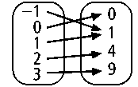

**2. Domain Range**

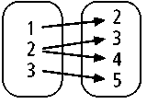

**3. Domain Range**

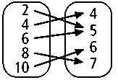

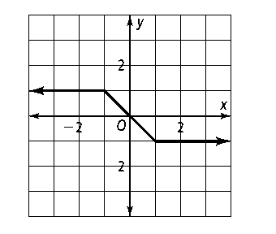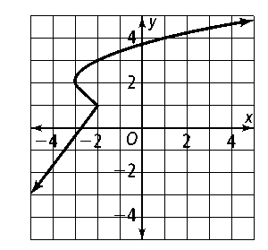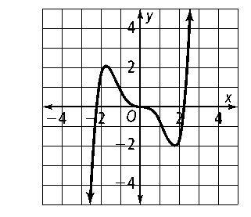**Use the vertical line test to determine whether each graph represents a function.**

**4. 5. 6.**

**Evaluate each function for the given value of *x*, and write the input *x* and the output *f* (*x*) as an ordered pair.**

**7.** *f*(*x*) = *−*3*x* + 2 for *x* = 3 **8.**

**Write a function rule to model the cost of renting a truck for one day. Then evaluate the function for the given number of miles.**

**9.** Daily rental: $19.95, Rate per mile: $.50 per mile, and Miles traveled: 73 miles

**Find the domain and range of each relation, and determine whether it is a function.**

**10.**

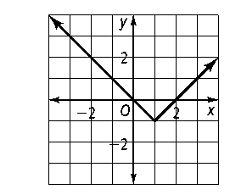

**For Exercises 11–12, *y* varies directly with *x*.** **11.** If *y* = 3 when *x* = *−*9, find *x* when *y* = 5. **12.** If *y* = *−*14 when *x* = *−*7, find *x* when *y* = 22.

**13.** The distance a spring stretches varies directly with the amount of weight that is hanging on it. A weight of 2.5 pounds stretches a spring 18 inches. What is the stretch of the spring when a weight of 6.4 pounds is hanging on it?

**14.** The amount of lemon juice in a lemonade recipe varies directly with the amount of water. The recipe calls for 8 oz of lemon juice and 32 oz of water. How much lemon juice should you use if you start with 28 oz of water?

**Find the slope of the line through each pair of points.**

**15.** (0, 1) and (3, 0) **16.** (−3, −2) and (1, 6) **17.** (4, −1) and (−2, −3)

**Write an equation for each line.**

**18.** *m* = −4 and the *y*-intercept is 3. **19. ** and the *y*-intercept is .

**Find the slope and *y*-intercept of each line.**

**20.** 3*x* − 4*y* = 12 **21. ** **22.** 4*x* − 3*y* = −6

**Find the slope and *y*-intercept of each line.**

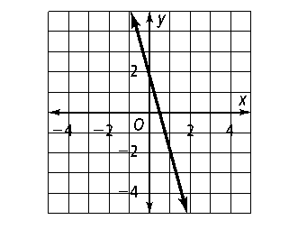 **23.**

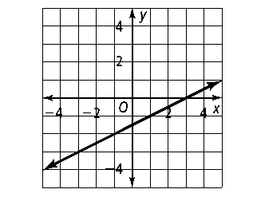**24.**

;kljdf