Name

Class

Date

**2.4 Practice**

**Find the slope of the line through each pair of points.**

**1.** (−3, −2) and (1, 6) **2.** (4, −1) and (−2, −3)

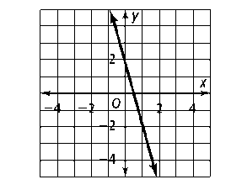**Write an equation of each line in slope intercept form.**

**3.** *m* = 4 and the *y*-intercept is -3 **4.**

**5.** slope −5; through (9, −1) **6.** slope ; through (−6, 7)

**Write in point-slope form an equation of the line through each pair of points. To start, substitute values for (*x*1, *y*1) and (*x*2, *y*2) into the slope formula. Then convert the point-slope form to slope intercept form.**

**7.** (2, 7) and (−2, 1) **8.** (3, -2) and (1, 4)

**Write an equation of each line in standard form with integer coefficients. To start, multiply each side by the least common denominator of all fractional coefficients.**

**9. $y=\frac{3}{7}x-2$ 10. $y=-\frac{5}{4}x+\frac{1}{3}$**

**11. Reasoning** The line *y* + 4 = (*x* − 8) contains point (*a*, 2). Find *a*. Show your work.

**12.** Rosa must read 20 pages of a book for English class. It will take Rosa about 50 minutes to complete her reading. Let ***x*** ***= the number minutes spent reading*** and ***y = number of pages read***. Draw a graph and write an equation to represent the situation (Hint: if you have read for 0 minutes, how many pages have you read?). According to your equation, how long will it take Rosa to read 30 pages?

**Write an equation in slope-intercept form for each line.**

**13.** the line parallel to *y* = 4*x* − 1 through (2, -7)

**14.** the line perpendicular to  through (6, 3)